23.25: a)
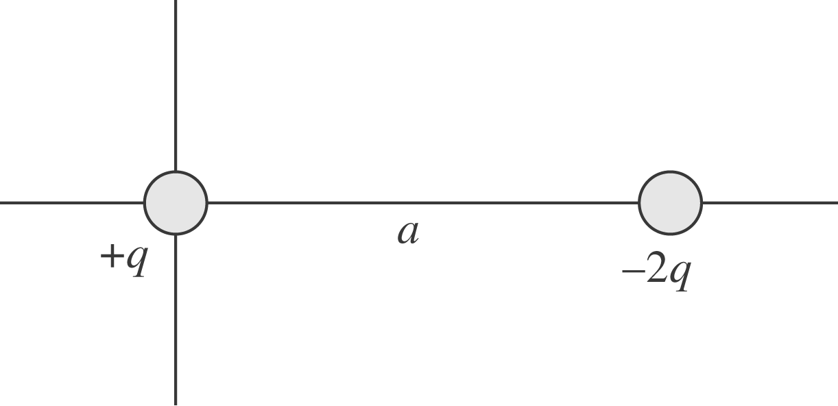
b) 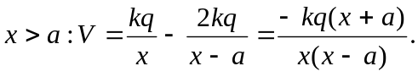
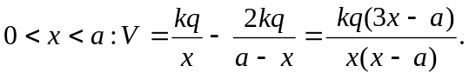
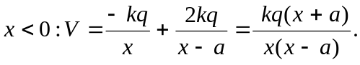
Note: This can be also be written as 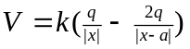
c) The potential is zero at 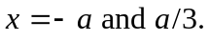

d)
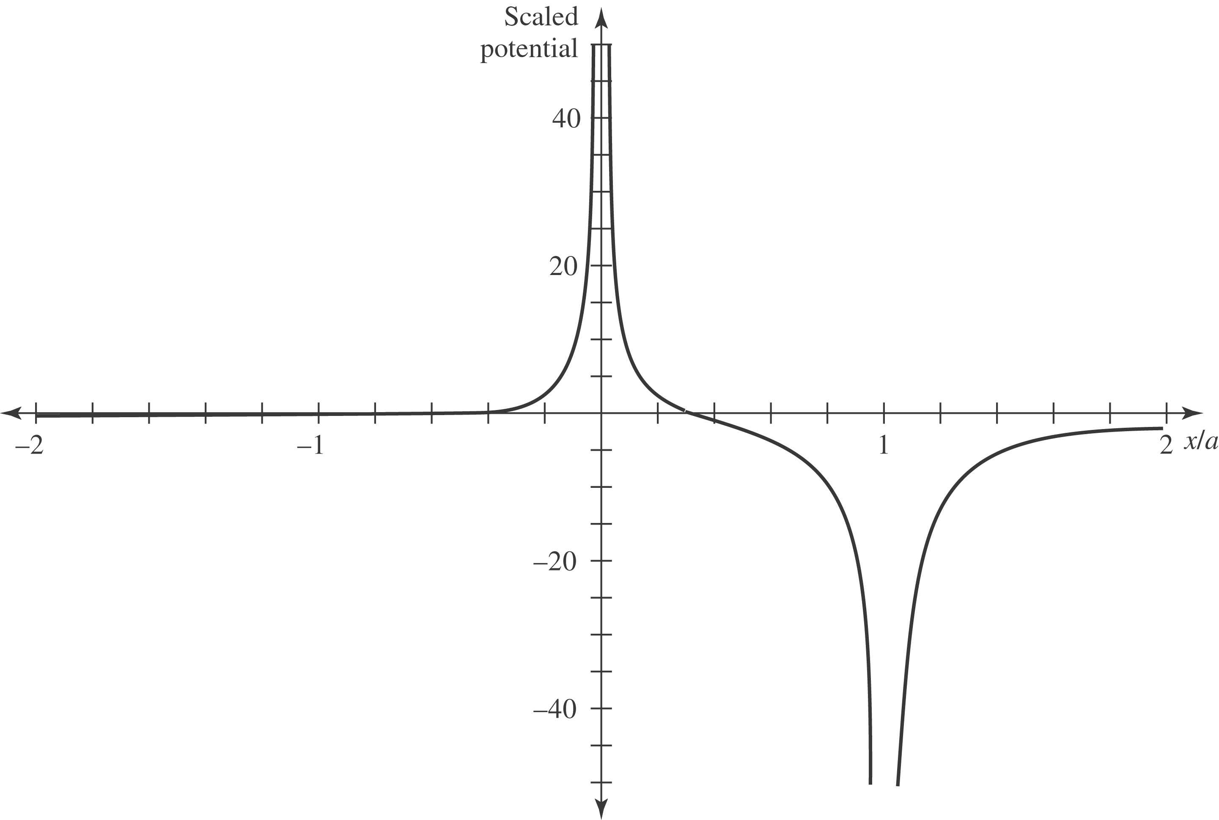
e) For 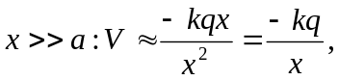 which is the same as the potential of a point charge –q. (Note: The two charges must be added with the correct sign.)

